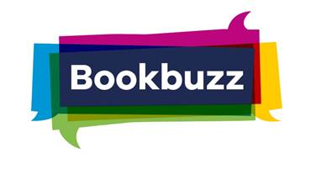
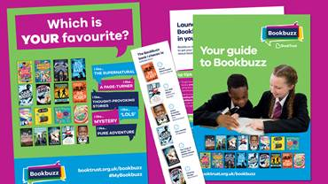
2020

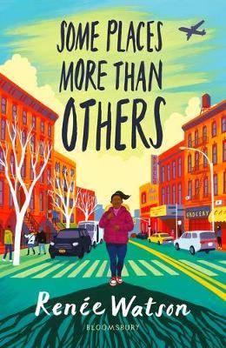
Some Places More Than Others by Renee Watson 11+
Amara desperately wants a trip to New York for her birthday, to meet her dad’s family and see where he grew up and she can’t understand why her parents are reticent about the trip. Until she discovers her dad hasn’t spoken to his dad, Grandpa Earl, for twelve years – not since the day she was born. What could make them so mad at each other?
Concepts of family history are neatly tied together with the extensive roots of black American history that are revealed to Amara, giving her a true sense of empowerment and identity. A textured, warm and positive story, beautifully written and with a poetic feel.
A Darkness of Dragons by S.A. Patrick 11+
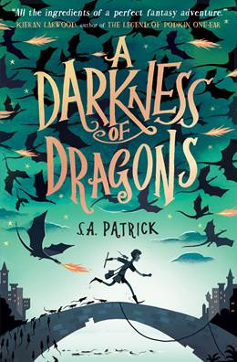
When Patch agrees to help find a way to break the curse that’s turned his friend Wren into a rat, he has no idea it’ll land him in quite as much trouble as it does.
With a classic adventure feel, this is a great book for anyone who loves epic quests and magical worlds to get lost in. There are dragon secrets, powerful sorcerers, magical stones, tricksy prophecies and an outlawed song that holds terrible power. A true roller-coaster ride of a book.

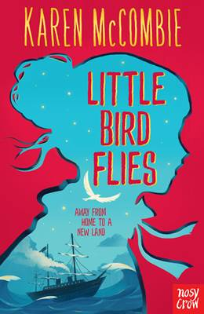
Little Bird Flies by Karen McCombie 11+
Bridie loves the tiny Scottish island where she lives, but can’t help dreaming of what lies beyond the boundaries of this small world; she’s determined that one day she’ll fly free and cross the ocean to America.
Little Bird Flies is a beautiful story of changing times and the upheaval of a small rural community, seen through the eyes of one young person. Set in the 1860s, the story chronicles rural life, family and friendship. It’s wonderfully told, with a hopeful and outward-looking perspective. Bridie is caring and compassionate, tied to her past, but filled with dreams of a different future.

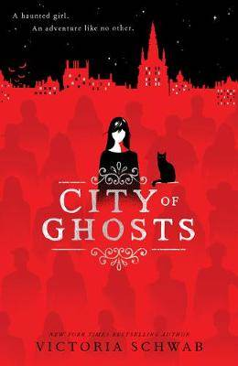
City of Ghosts by Victoria Schwab 11+
Instead of summer at the beach, Cassidy’s parents have dragged her on a trip to Edinburgh to film their new TV show. This wouldn’t be so bad, except that since her near-death experience last year, Cass has been able to see and feel ghosts whenever they’re near –and Edinburgh is one of the most haunted cities in the world.
Hooking you from the very first page, it has just the right amount of spookiness, mystery and action, keeping you on the edge of your seat without getting gory. Victoria Schwab is a superb storyteller, blending well-crafted characters with a perfectly paced plot. A ridiculously fun, spine-tingling read.

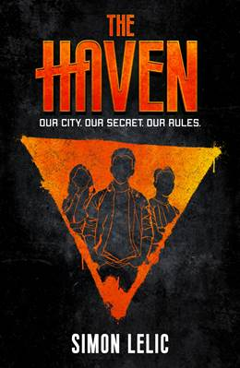
The Haven by Simon Lelic 11+
When Ollie’s pulled from his bed by masked men in the middle of the night and his guardian, Nancy, is murdered, it’s only thanks to the help of street kid Dodge that he survives. Dodge takes Ollie to The Haven: a secret refuge for kids with nowhere else to go. Run by the children themselves, The Haven helps get lost or homeless kids off the streets and give them a new start.
A well-layered action thriller, this is perfect for readers who enjoy a tense story packed with life-threatening danger. A number of different threads run through it that the author very cleverly pulls together in the dramatic finale.

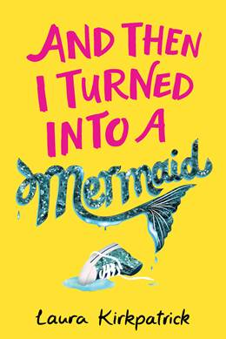
And Then I Turned Into a Mermaid by Laura Kirkpatrick 11+
Molly Seabrook really just wants to be normal. And popular if possible. But when, at midnight on her thirteenth birthday, her mum and older sisters take her on a mysterious trip to the beach and reveal that she’s half-mermaid, Molly knows with absolute certainty that normal is never going to happen.
A brilliantly insightful and super fun story about growing up, navigating friendships and first crushes, and figuring out how you fit in. This book covers all the emotions but with a great sense of humour.

Talking to Alaska by Anna Woltz 11+
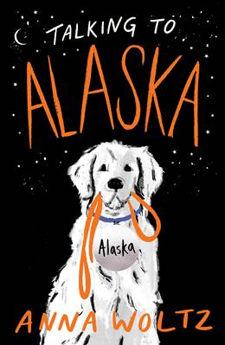
It only takes one day at their new school for Parker and Sven to become mortal enemies. Parker’s had a terrible summer and just wants to be invisible, while Sven is desperate to make an impression and be known as anything other than ‘that kid with epilepsy.’ When Parker discovers her beloved dog Alaska – who she had to give away last year – now belongs to Sven, she’s determined to steal her back. Of course, that’s much easier said than done…
Told in alternating chapters between the two characters, this is a heartfelt story about understanding others.

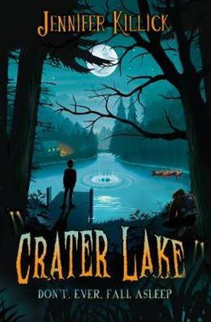
Crater Lake by Jennifer Killick 11+
There are three rules for surviving Crater Lake: don’t go anywhere with an adult; don’t follow any instructions you’re given; and don’t ever fall asleep… When Lance’s class arrives at the brand new Crater Lake activity centre for their school trip, it’s immediately clear something is not quite right. Aside from a weird lack of staff and a very odd manager, there’s also the panicked man covered in blood shouting at them all to run.
Crater Lake is a fast-paced, high action read full of suspense, scares, twists and turns. Alongside the action, there’s witty dialogue and a strong message about staying loyal to your friends and how to stand up for yourself against bullies, whether they’re mean kids, monstrous teachers – or even body-snatching aliens.
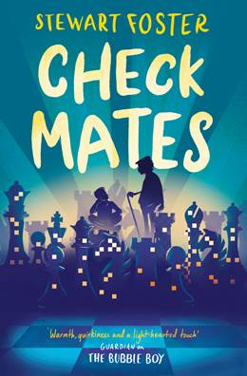
Check Mates by Stewart Foster 11+
Felix feels like he’s permanently in trouble at school. His mind is constantly changing direction, making it impossible to concentrate, and no-one gets how frustrating it is. When his Granddad decides teaching Felix to play chess will help, Felix will do anything to get out of it. But playing chess leads Felix to some surprising discoveries, from what it feels like to be good at something, to the dark secret that his Granddad has been hiding for nearly 60 years.
A well-constructed and thought-provoking real-life drama. Grandad’s cold war storyline brings in an additional element of interest and intrigue as Felix tries to untangle and understand his Granddad’s past.

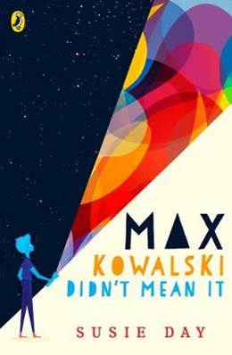
Max Kowalski Didn’t Mean It by Susie Day 11+
Max has a terrible habit of getting in trouble – he really doesn’t mean it, but somehow things just go wrong. His home life is tough too: since mum died, Max’s dad works several jobs and Max has to help look after his three little sisters. Then, after one too many not-quite-legal jobs, Dad gets into trouble too and leaves Max all alone to look after his three little sisters.
A remarkable book about families, being a boy and coping with loss. The characters are supremely well written, the author sensitively exploring how there are different ways to be a man and how boys are shaped into men. An emotional read about real-life challenges and figuring out where you belong.

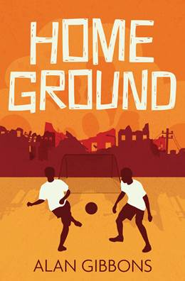
Home Ground by Alan Gibbons 11+
Sam’s football team is second to last in their league and desperate not to be relegated. When Sam recruits skilled players Hasan and Faisal to join the team, it looks like their luck might finally change. For Hasan and Faisal, though, who are refugees, football means much more than winning a few games.
Printed in a dyslexia-friendly font, it’s a great read both for anyone who likes books football and sports, or anyone looking for a shorter read with real-life concerns.

The Switch Up by Katy Cannon 12+
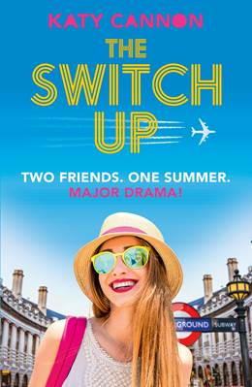
Willa and Alice meet for the first time in the unaccompanied minors lounge at LAX airport. They look so alike that they’re mistaken for sisters, but in reality they’re chalk and cheese. They’re both being sent away for the summer: Willa to Italy to stay with an aunt she’s never met; Alice to London to stay with the girlfriend she didn’t even know her dad had. When Alice suggests they swap places, she’s joking – but Willa is 100% serious when she says yes. It’ll be the adventure of a lifetime! Besides, no-one will ever find out… will they?
Each girl has a personal reason behind this dramatic decision and as we follow each of their stories, their different summers help them come to terms with the changes in their lives. It’s lighthearted and fun whilst touching on themes of parental separation, grief, foster care and growing up. A highly relatable feel-good read about discovering the true meaning of family and friendship.

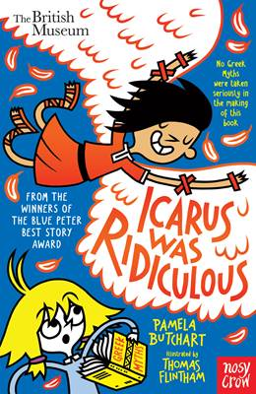
Icarus was Ridiculous by Pamela Butchart 10+
Izzy and her friends are on a class trip to the British Museum. When one classmate fails to pay attention to the teacher, holding everyone up, Izzy’s inspired to tell the story of Icarus who, after failing to listen to his dad’s instructions, flies too close to the sun with his wax wings, with catastrophic results.
A truly original take on some famous classical tales. The way in which Izzy characterises the stars of each story through their behaviour is especially enjoyable, and Thomas Flintham’s illustrations add that extra level of fun.

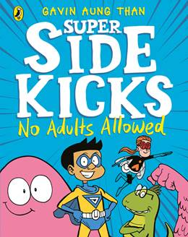
Super Sidekicks: No Adult Allowed by Gavin Aung Than 7+
JJ and his friends Fly Girl and Dinomite are sick of being taken for granted by the adult superheroes they work for. It’s time to stage a revolution and prove that they’re not just sidekicks!
An excellent, super-fun mini graphic novel (in black and white) that perfectly captures the superhero genre whilst also speaking to any reader who’s ever felt unfairly undervalued just because they’re a child. The adults are of course also completely blinkered when it comes to Goo, and it takes the kids to help them open their eyes. A clever story of empowerment told in a fresh new voice and wrapped up in a superhero comic package.

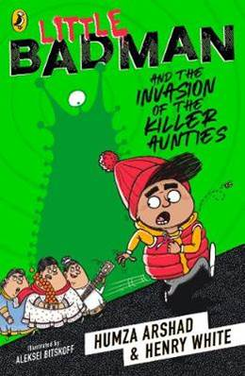
Little Badman and the Invasion of the Killer Aunties by Humza Arshad and Henry White 10+
Humza (aka Little Badman) great ambition is to be a super cool rapper and he devotes most of his time and energy on pursuing this goal. Something weird is happening at school though: teachers are disappearing and being replaced by food-obsessed Aunties intent on fattening everyone up! When his music teacher vanishes, putting a halt to Humza’s rapper dreams, he’s determined to figure out what’s going on – and then things start to get really crazy...
Fast-paced and funny, full of action and humour, but perhaps best of all is how Humza grows and changes through the story, and gets his dad to too.

Real-Life Mysteries by Susan Martineau 9+
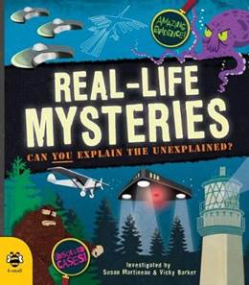
Is there really a Loch Ness monster? Can people really bend a spoon using just their mind? Are crop circles really created by aliens? This book examines some of the biggest mysteries and apparent supernatural occurrences from around the world to try and figure out if they’re real – or something else.
A great book for anyone who likes fun facts and to dip into books and pore over details and think about things a little differently. Engaging and entertaining, it also subtly helps readers learn how to discriminate and assess real facts from false or misleading ones, a useful skill for anyone to learn, especially in the age of ‘fake news.’

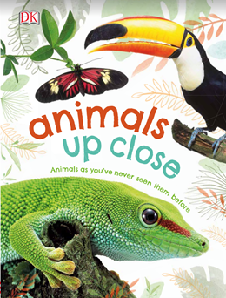
Animals Up Close by Dorling Kindersley 6+
Did you know that you can count the ring patterns on a tortoise’s shell to find out how old they are? Or that seahorses are actually fish? Animals Up Close showcases over thirty creatures with close-up photographic images and simple facts about how they live and the special adaptations they have that help them survive.
Flick through this book, dip in and out, read it cover to cover, or just enjoy looking at the photographs. Which creature have you never heard of before? Which one has the most surprising adaptation? And which one will be your favourite?

